|  |  |
| --- | --- |
| #include<bits/stdc++.h>  using namespace std;  #define ll long long int  #define MAX 100000000  int main()  {  int n;  cout<<"Enter the number of node : ";  cin>>n;  ll ara[n][n];  for(int i=0; i<n; i++)  {  for(int j=0; j<n; j++)  {  cin>>ara[i][j];  if(ara[i][j]==0)  {  ara[i][j]=MAX;  }  }  }  cout<<"Graph represented matrix : \n";  for(int i=0; i<n; i++)  {  cout<<"\t";  for(int j=0; j<n; j++)  {  if(ara[i][j]==MAX)  cout<<"inf"<<" "; | else  cout<<ara[i][j]<<" ";  }  cout<<endl;  }  for(int k=0; k<n; k++)  {  for(int i=0; i<n; i++)  {  for(int j=0; j<n; j++)  {  ara[i][j]=min(ara[i][k]+ara[k][j],ara[i][j]);  }  }  }  cout<<"Shortest Path: \n";  for(int i=0; i<n; i++)  {cout<<"\t";  for(int j=0; j<n; j++)  {  if(ara[i][j]==MAX)  cout<<"inf"<<" ";  else  cout<<ara[i][j]<<" ";  }  cout<<endl;  }  } |

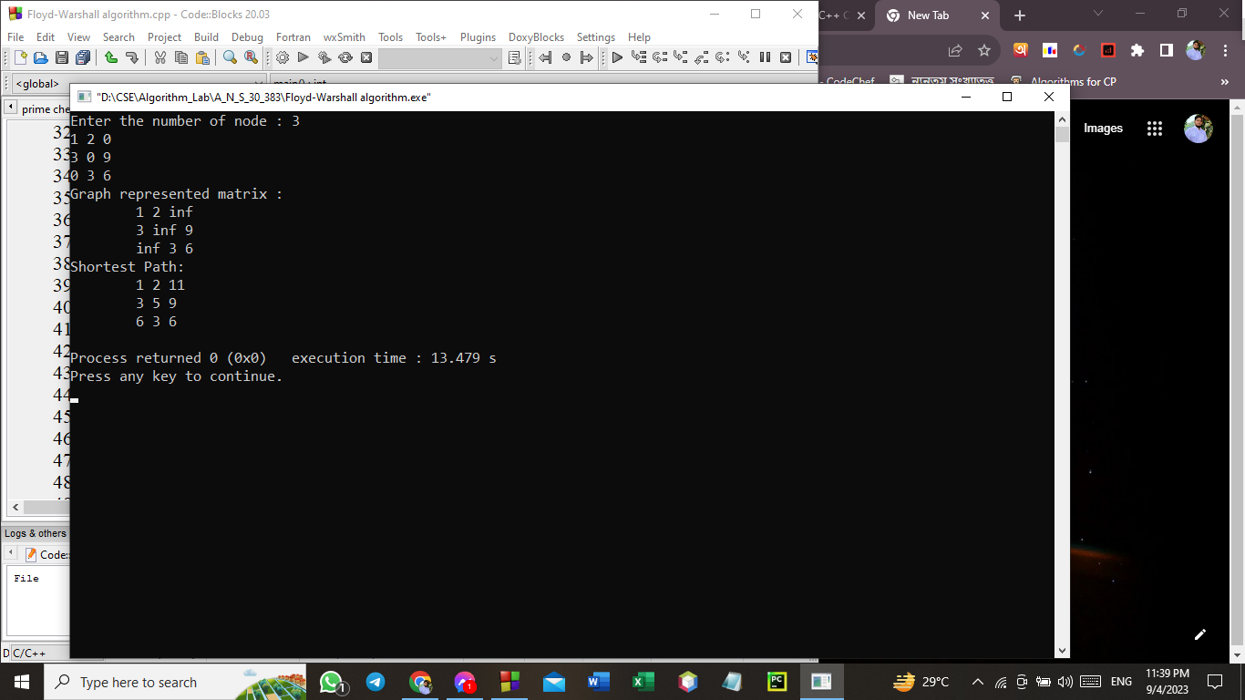

|  |  |
| --- | --- |
| #include<bits/stdc++.h>  using namespace std;  #define ll long long int  #define inf 100000000  vector<pair<ll, ll>> g[101];  ll v, e;  void floydWarshall()  {  vector<vector<ll>> dist(v, vector<ll>(v, inf));  for (ll i = 0; i < v; i++)  {  dist[i][i] = 0;  for (const pair<ll, ll>& edge : g[i])  {  ll j = edge.first;  ll weight = edge.second;  dist[i][j] = weight;  }  }  for (ll k = 0; k < v; k++)  {  for (ll i = 0; i < v; i++)  {  for (ll j = 0; j < v; j++)  {  if (dist[i][k] != inf && dist[k][j] != inf)  dist[i][j] = min(dist[i][j], dist[i][k] + dist[k][j]);  }  }  }  cout<<"Distance From Source '0' to every vertex : \n";  cout<<"Vertex\tDistance From Source\n";  for(ll i=0; i<v; i++)  {  cout<<i<<"\t\t"<<dist[0][i]<<endl;  } | cout<<endl;  cout<<"Matrix form of shortest path : \n";  for (ll i = 0; i < v; i++)  {  for (ll j = 0; j < v; j++)  {  if (dist[i][j] == inf)  cout << "inf" << " ";  else  cout << dist[i][j] << " ";  }  cout << endl;  }  }  int main()  {  cout << "Enter the number of vertices and edges : ";  cin >> v >> e;  for (ll i = 0; i < e; i++)  {  ll x, y, c;  cin >> x >> y >> c;  g[x].push_back({y, c});  }  floydWarshall();  return 0;  } |

|  |  |
| --- | --- |
| #include<bits/stdc++.h>  using namespace std;  #define ll long long int  ll solve(ll var_Mn[],ll mod_v[],ll i)  {  ll x=1;  while(true)  {  ll rem=(var_Mn[i]*x)%mod_v[i];  if(rem==1)  {  return x;  break;  }  x++;  }  }  int main()  {  ll n;  cout<<"Enter the number of equation : ";  cin>>n;  ll ara[n],mod_v[n],var_Mn[n],var_M_in[n];  for(int i=0; i<n; i++)  {  cout<<"Enter the value of a"<<i+1<<" = ";  cin>>ara[i];  } | cout<<endl;  for(int i=0; i<n; i++)  {  cout<<"Enter the value of m"<<i+1<<" = ";  cin>>mod_v[i];  }  ll M=1;  for(int i=0; i<n; i++)  {  M*=mod_v[i];  }  for(int i=0; i<n; i++)  {  var_Mn[i]=(M/mod_v[i]);  }  for(int i=0;i<n;i++)  {  var_M_in[i]=solve(var_Mn,mod_v,i);  }  ll X=0;  for(int i=0;i<n;i++)  {  X+=ara[i]*var_Mn[i]*var_M_in[i];  }  cout<<"\nValue of X = ";  cout<<X%M<<endl;  } |

